Paris Principles - needs to be a part of any proposal

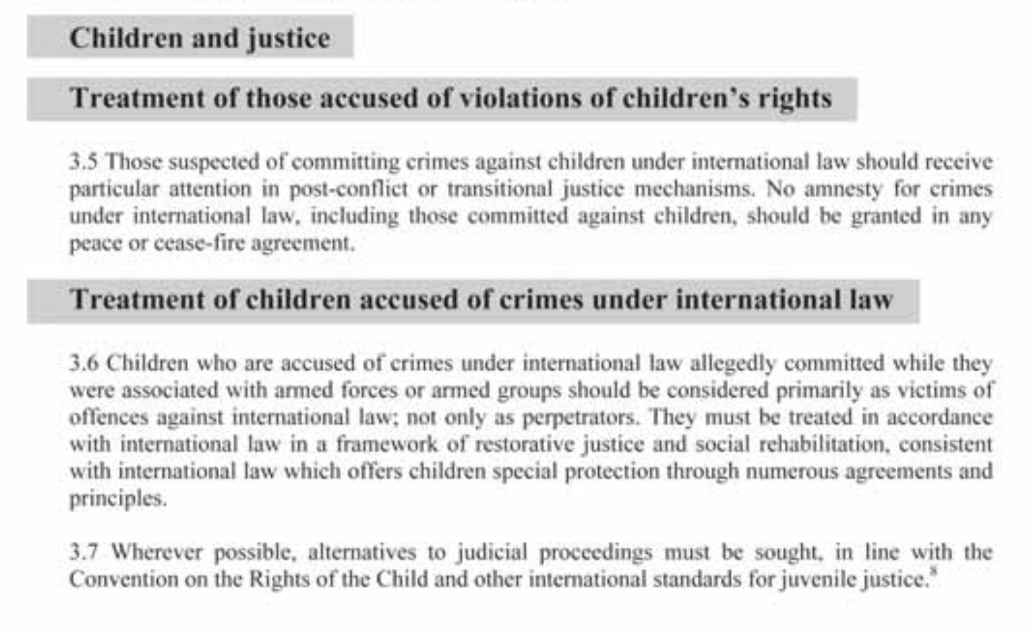

Marisa presentation (GAM)

* Post-conflict Aceh focus
* Reconciliation began post-Tsunami in 2005
  + Instigated a lot of international aid
* Lots of economic development work happening around this time related to the tsunami, but not necessarily to the reintegration
* Indonesian Reintegration Agency (BRA)
  + GAM would not give government a list of the former combatants
  + 50,000 applications from victims
  + Used World Bank funds
* Was it successful
  + Relatively little violence since
  + Conflict within GAM over distribution of funds
  + Peaceful elections
  + Shari-a law
* Key takeaways
  + Need to hold military accountable
  + Hard to identify victims
* Similarities
  + Child soldiers
  + Military abuses
  + Religious Aspect
  + Oil and Economic Inequality
* Differences
  + Huge influx of international aid due to tsunami
  + Geographic differences  
     Easier to contain insurgencies on islands

Casey: primary concern of Nigerian governors was attracting foreign investment to the north - not as concerned about reintegrating Boko Haram

We’ll have visitors to class on the 10th and 17th

People from “Plateau State” are willing to meet with us. Maybe on a Friday (they are six hours ahead)

Questions

* Is there Chinese investment in Nigeria?
  + Justin: a little bit - just getting started
* Do the northern Nigerian governors think that foreign investment is contingent on reintegrating Boko Haram?
  + Casey: No - seem to buy into the narrative that Boko Haram is on the run
* Should there be some kind of retributions for the alleged extrajudicial killing of Yusuf
* 3 million IDPs in Nigeria
  + Many malnourished

Survey

* Casey: governors did not think that survey is a good tool to gauge public sentiment
* Aprille: this offers a unique opportunity to connect with the general population, rather than
* Crimson Hexagon for gauging public sentiment
* Should we tell UNCTED about the survey?
  + Ellen: pitch our initial questions to the UN
* We can meet with the Yale analytical center next Tuesday